PlayfulOutings
Picnic Games & Getaways

eProject Documentation Report
Semester 1 — HTML5 Web Development | Aptech Computer Education

Submitted by:
Chukwu Nathan Emeka
Daniel Fortune Rohi
Chukwu Stanley Ebuka
Daniel Chinonso Favour

March 2026 | Abuja, Nigeria

Making every outing memorable • Abuja, Nigeria • March 2026

1. Acknowledgements
We thank Aptech Computer Education, our instructors, and our group members — Chukwu Nathan Emeka, Daniel Fortune Rohi, Chukwu Stanley Ebuka, and Daniel Chinonso Favour — for their dedication throughout this project. We also acknowledge the open-source community, YouTube creators, and Google Maps.

2. eProject Synopsis
Field | Details
Project Title | PlayfulOutings — Picnic Games & Getaways
Type | Single-Page Application (SPA) Website
Stack | HTML5, CSS3, Vanilla JavaScript
Team | Chukwu Nathan Emeka, Daniel Fortune Rohi, Chukwu Stanley Ebuka, Daniel Chinonso Favour
Date / Location | March 2026 — Abuja, Nigeria
Institution | Aptech Computer Education — Semester 1

3. Problem Definition
Families and friends in Abuja struggle to organise enjoyable picnics due to:
- Lack of ready-to-use games: No single platform for age-appropriate games with clear instructions and timings.
- Repetitive gatherings: Unstructured gatherings become boring and unmemorable.
- No localised plans: No Abuja-specific getaway plans (Jabi Lake, Millennium Park, Usuma Dam).
- Difficulty organising groups: Mixed-group organisation required searching multiple sources.
Solution: PlayfulOutings provides curated indoor & outdoor games, itinerary suggestions, and interactive features — all accessible from any browser.

4. eProject Analysis
Functional Requirements
- 24 curated games across 6 categories (Indoor, Outdoor, Kids, Males, Females, Family).
- Materials, time, and how-to-play per game; embedded YouTube demos; downloadable .docx guides.
- Abuja-specific itineraries, Google Maps embed, persistent visitor counter, live geolocation ticker.
- Category filter (sub-nav & header dropdown), smooth scrolling, active link highlighting.

Non-Functional Requirements
Requirement | Description
Performance | Lazy-loaded videos; no backend required.
Responsiveness | CSS Grid, Flexbox, media queries — fully mobile-friendly.
Compatibility | Chrome, Firefox, Edge, Safari — all supported.
Usability | Intuitive nav, clear visual hierarchy.
Maintainability | Clean commented code: 3 files (HTML, CSS, JS).

5. eProject Design (Diagrams — see Page 3)
DFD Context Diagram
Level 0 DFD: PlayfulOutings system (ellipse) interacts with USER (click/navigate ↔ content), localStorage (read/write visitor count), YouTube API (video embeds), and Geolocation API (location data).
User Navigation Flowchart
START → Page loads (Indoor default) → Decision: Games / Itineraries / About-Contact → Games: select category → view/watch/download → END.
System Internal Flow
Page Load → hide all categories → showCategory('indoor') → localStorage check (increment or start at 1) → display count → Geolocation check (coords or 'denied') → start ticker → Site Ready.
Game Category Filter Process
1. User clicks category 2. JS intercepts click 3. showCategory(id) called 4. All .game-category divs hidden 5. Target shown 6. Active class updated 7. Smooth-scroll to Games.

6. Design Specifications
Technology | Purpose / Details
HTML5 | Semantic tags, sections, iframes, Geolocation API
CSS3 | Glassmorphism, CSS Variables, Flexbox, Grid, Animations
JavaScript ES6 | DOM manipulation, localStorage, Geolocation, Events
Google Maps | Millennium Park embed in Contact section
YouTube Embed | Lazy-loaded game tutorial videos
localStorage | Persistent visitor counter across sessions
Google Fonts | Poppins (body), Press Start 2P (hero title)

CSS Variable | Hex / Value — Usage
--primary | #357d2c — Buttons, labels, card headers
--primary-dark | #1e5c38 — Hover states
--accent | #f4a261 — Call-to-action highlights
--glass | rgba(255,255,255,0.12) — Glassmorphism nav
--text | #ffffff — Primary text on dark backgrounds

5. eProject Design — Diagrams

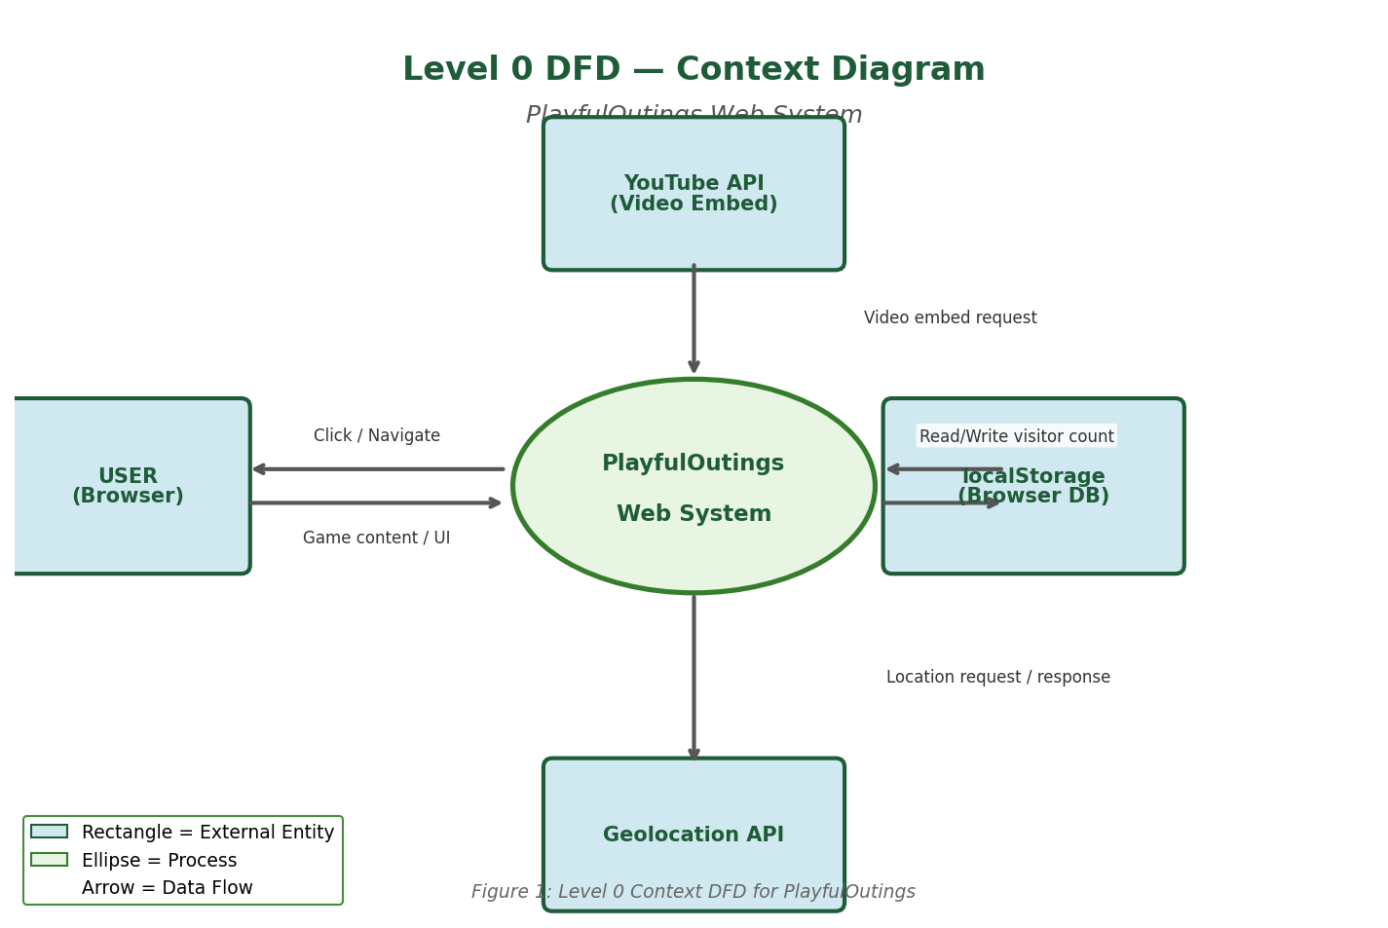 | 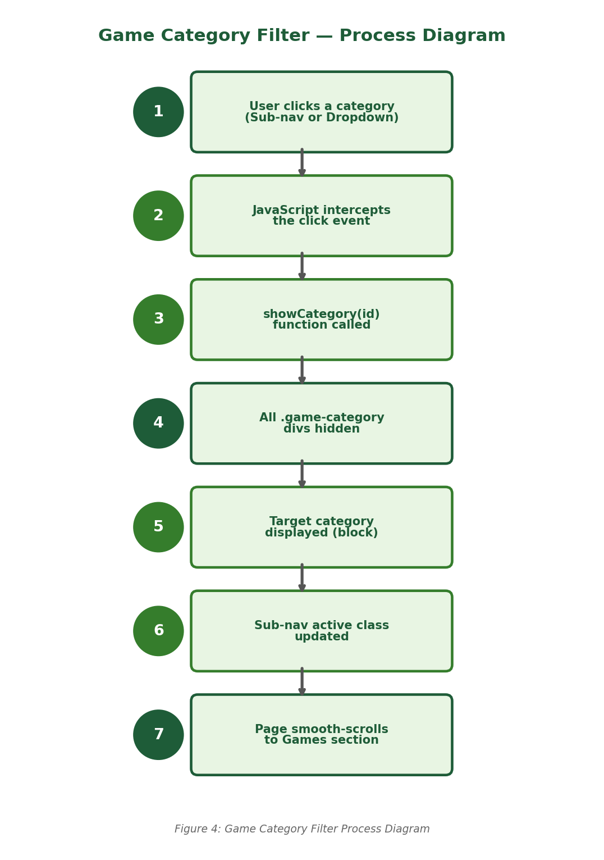
Fig 1: Level 0 Context DFD | Fig 4: Category Filter Process

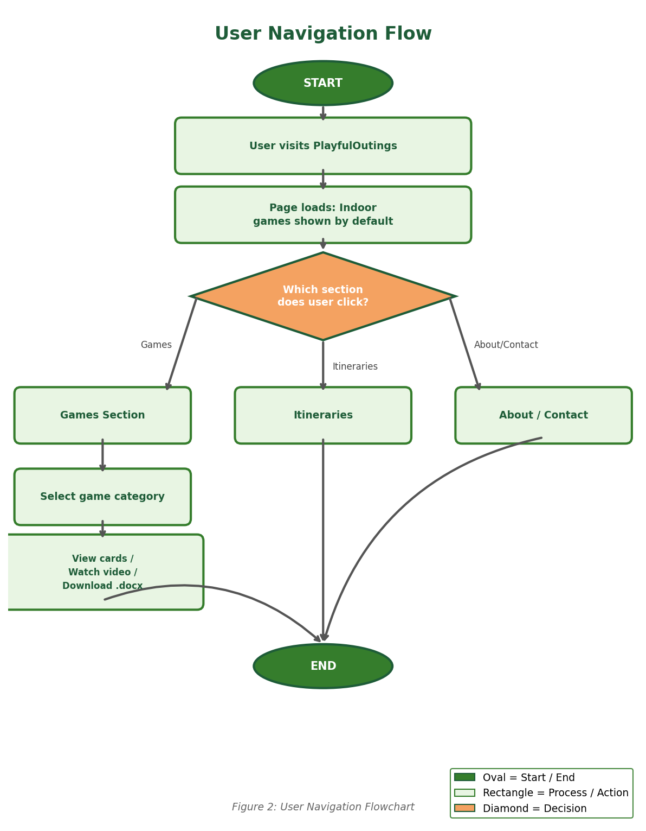 | 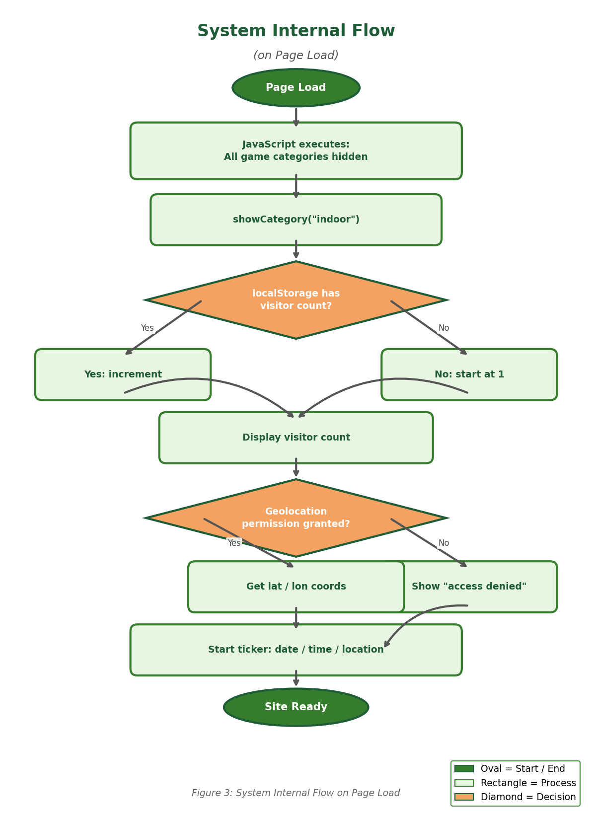
Fig 2: User Navigation Flowchart | Fig 3: System Internal Flow

8. Source Code (Key Snippets)
Visitor Counter (script.js)
let visits = localStorage.getItem('playfuloutings_visits') || 0;
visits = Number(visits); if (isNaN(visits)) visits = 0;
visits += 1; localStorage.setItem('playfuloutings_visits', visits);
Category Filter (script.js)
function showCategory(id) {
gameCategories.forEach(c => c.style.display = c.id===id?'block':'none'); }
showCategory('indoor'); // default on load
YouTube Lazy Load
wrapper.addEventListener('click', () => {
iframe.src = `https://www.youtube.com/embed/${videoId}?autoplay=1`; });
Geolocation + Ticker
navigator.geolocation.getCurrentPosition(
pos => { locEl.textContent = `Lat: ${pos.coords.latitude}`; });
setInterval(updateTicker, 1000);

9. User Guide
Open index.html in any modern browser — no installation needed. Allow location access for the full ticker experience.
- Top nav bar → Home, Games (dropdown with 6 categories), Itineraries, About, Contact.
- Sub-nav pills (Indoor/Outdoor/Kids/Males/Females/Family) filter the games section.
- Each game card: Materials, Time, How-to-Play, video thumbnail, and .docx download.
- Contact section shows email, phone, Google Maps, and live geolocation coordinates.
- Ticker at bottom scrolls current date, time, and location. Visitor counter top-right.

7. Screenshots Description

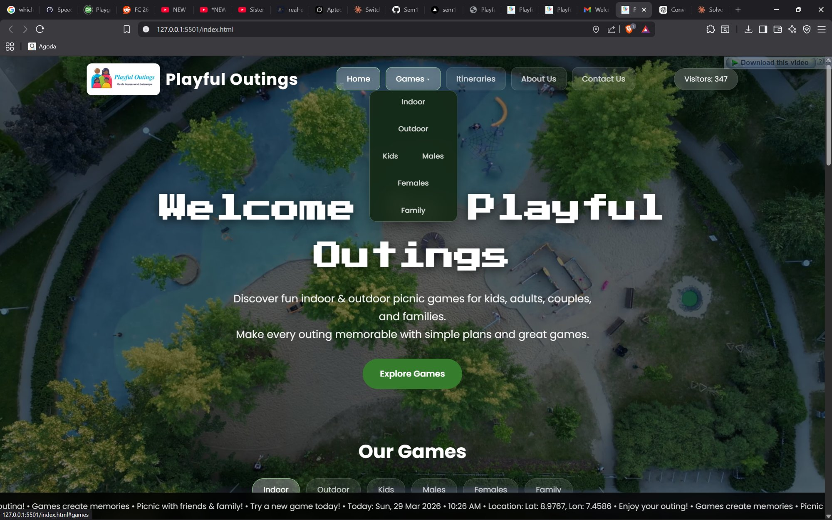 | 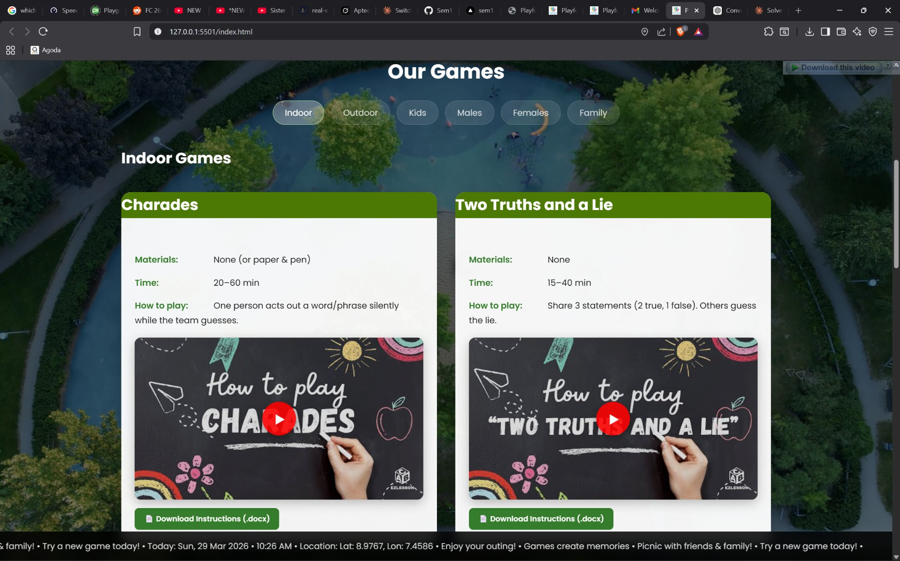
Screen 1 — Hero / Home Section | Screen 2 — Indoor Games (Charades & Two Truths)

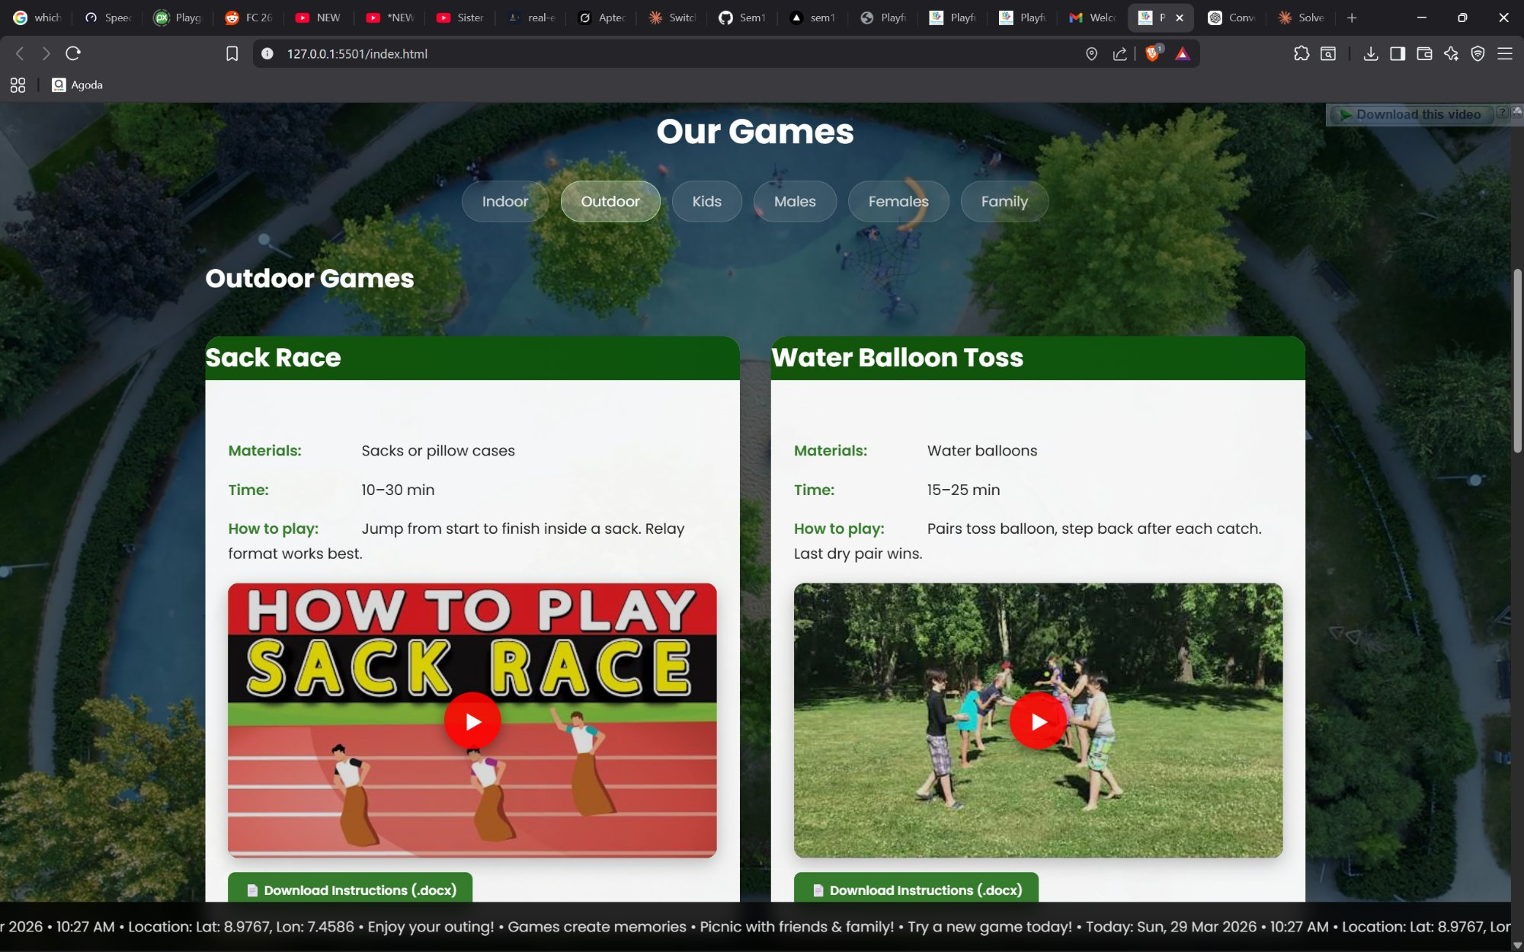 | 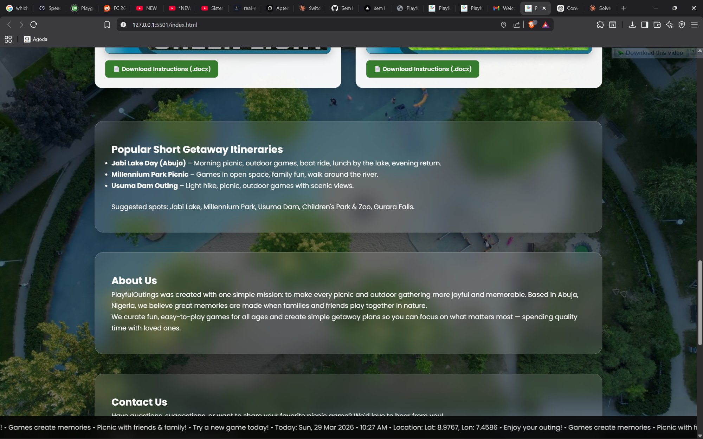
Screen 3 — Outdoor Filter Active | Screen 4 — Itineraries & About Us

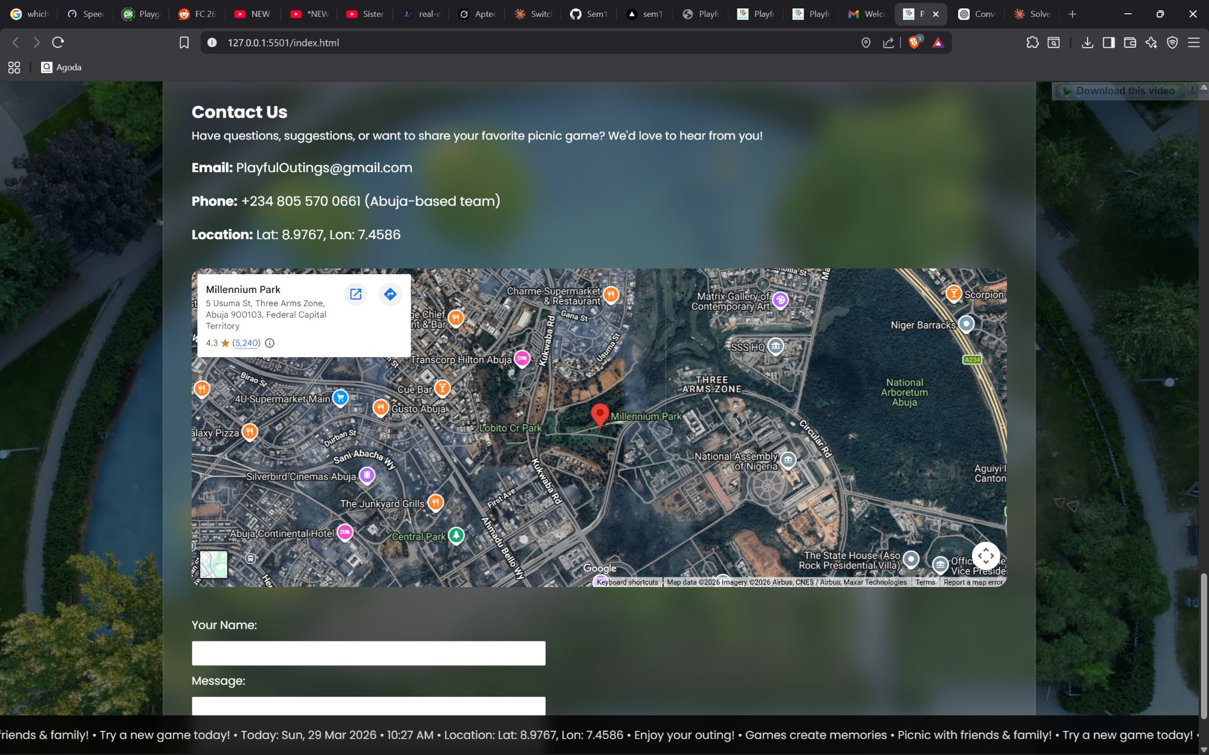 | 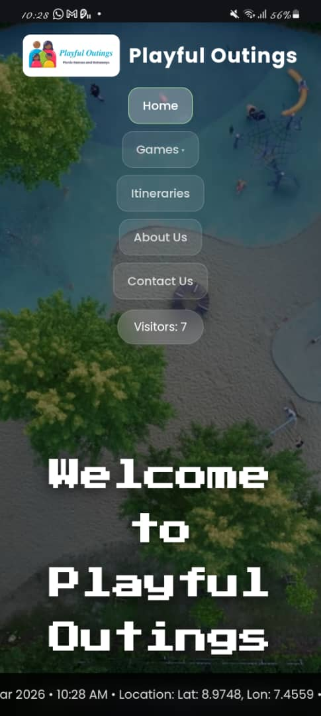
Screen 5 — Contact Section & Map | Screen 6 — Mobile View

10. Developer's Guide
File / Folder | Description
index.html | Main HTML — all sections and content
style.css | Styling — layout, components, animations, responsive
script.js | JavaScript — filter, ticker, geolocation, lazy load
game_docs/ | 24 .docx game instruction files
videos/ | bg-video.mp4, bg-poster.png, Logo.png

Module Descriptions
- Visitor Counter — localStorage persists visit count; NaN-guarded; updates #visitorCount span.
- Category Filter — showCategory(id) hides all .game-category divs, shows target, updates active class.
- YouTube Lazy Load — iframe created on thumbnail click with autoplay=1; guard prevents duplicates.
- Geolocation & Ticker — getCurrentPosition() feeds #userLocation; updateTicker() runs every 1000ms.
- Smooth Scroll & Nav — preventDefault() + scrollIntoView({behavior:'smooth'}); scroll listener sets .active.
- CSS Variables — :root properties update colours site-wide; glassmorphism via backdrop-filter:blur().
- Responsive — breakpoints: 992px (stack header), 768px (single-col grid), 480px (smaller fonts).

How to Add a New Game
- Add .game-card div inside relevant .game-category in index.html.
- Include .info-item divs for Materials, Time, How to Play; add .yt-lazy div with data-videoid.
- Add .download-btn pointing to new .docx in game_docs/. No JS or CSS changes needed.

Browser | Status
Chrome 120+ | ✔ Fully Supported
Firefox 121+ | ✔ Fully Supported
Edge 120+ | ✔ Fully Supported
Safari 17+ | ✔ Fully Supported
Opera 106+ | ✔ Fully Supported

PlayfulOutings — eProject Documentation | Aptech Computer Education | March 2026

